FSM Assignment Jakob Lutch

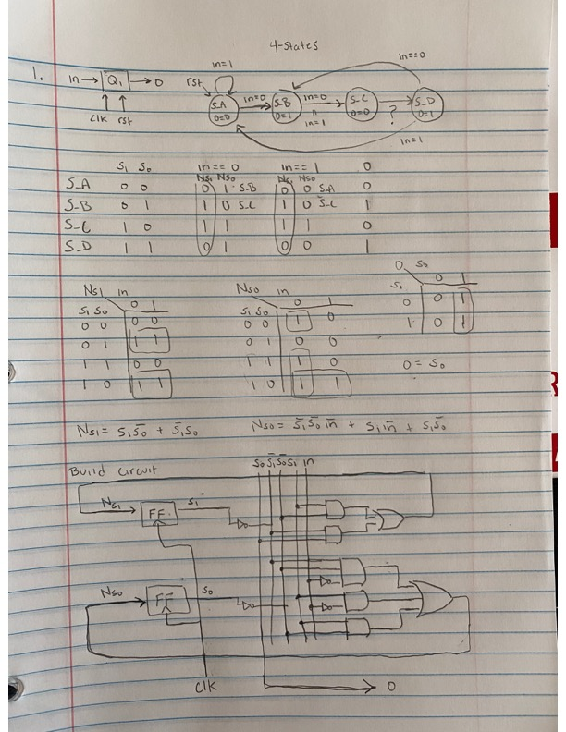

Fig1. Displays question 1 for the assignment.

1. Verilog code for question 1
2. module q1(
3. input clk, rst, in,
4. output reg o
5. );
6. reg [1:0] s;
7. reg [1:0] Ns;
8. parameter s_A = 2'b00,
9. s_B = 2'b01,
10. s_C = 2'b10,
11. s_D = 2'b11;
12. always@(posedge clk or negedge rst)
13. if(rst == 1'b0)
14. s <= s_A;
15. else
16. s <= Ns;
18. always@(*)
19. case(s)
20. s_A: if(in == 1'b0)
21. Ns = s_B;
22. else
23. Ns = s_A;
24. s_B: if(in == 1'b0)
25. Ns = s_C;
26. else
27. Ns = s_C;
28. s_C: if(in == 1'b0)
29. Ns = s_D;
30. else
31. Ns = s_D;
32. s_D: if(in == 1'b0)
33. Ns = s_B;
34. else
35. Ns = s_A;
36. default: Ns = s_A;
37. endcase
39. always@(*)
40. if(s == s_B | s == s_D)
41. o = 1'b1;
42. else
43. o = 1'b0;
45. Endmodule

3. Question 3

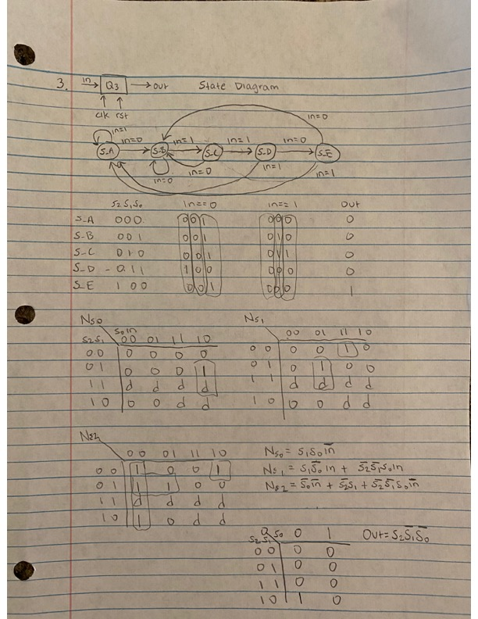

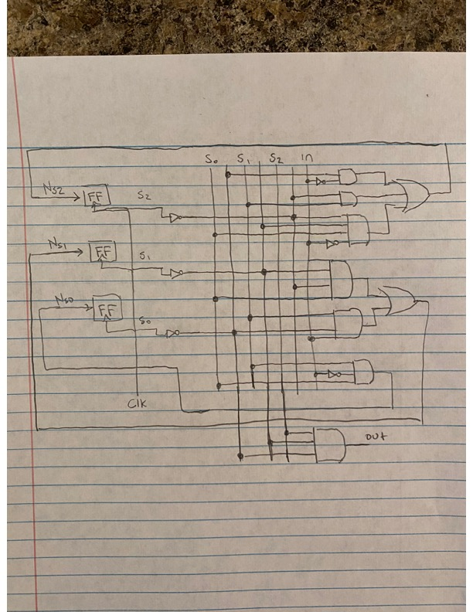

module q3(

input clk, rst, in,

output reg o

);

reg [2:0] s;

reg [2:0] Ns;

parameter s_A = 3'b000,

s_B = 3'b001,

s_C = 3'b010,

s_D = 3'b011,

s_E = 3'b100;

always@(posedge clk or negedge rst)

if(rst == 1'b0)

s <= s_A;

else

s <= Ns;

always@(*)

case(s)

s_A: if(in == 1'b0)

Ns = s_B;

else

Ns = s_A;

s_B: if(in == 1'b0)

Ns = s_B;

else

Ns = s_C;

s_C: if(in == 1'b0)

Ns = s_B;

else

Ns = s_D;

s_D: if(in == 1'b0)

Ns = s_E;

else

Ns = s_A;

s_E: if(in == 1'b0)

Ns = s_B;

else

Ns = s_A;

default: Ns = s_A;

endcase

always@(*)

if(s == s_E)

o = 1'b1;

else

o = 1'b0;

endmodule

*Verilog code for question 3

5. State Diagram

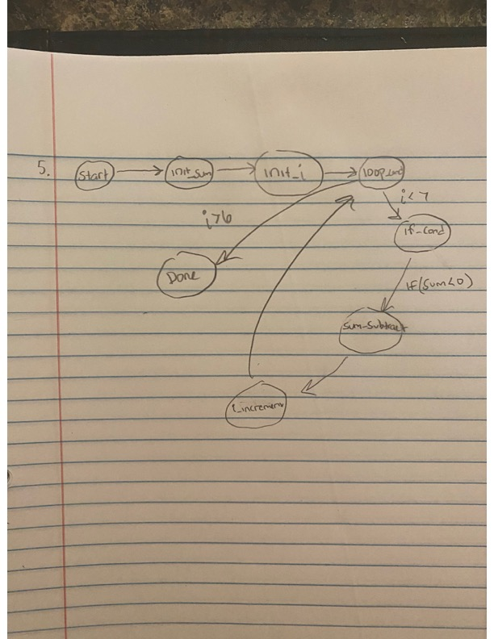

Fig. General state diagram for 5.

module q1(

input clk,

input rst,

input [7:0] input_1,

input [7:0] input_2,

output reg [7:0] sum,

output reg done

);

reg [3:0] s;

reg [3:0] Ns;

parameter START = 4'd0,

init_sum = 4'd1,

init_i = 4'd2,

loop_cond = 4'd3,

if_cond = 4'd4,

sum_subtract = 4'd5,

i_increment = 4'd6,

DONE = 4'd7,

ERROR = 4'hF;

reg [7:0] loop_thresh;

reg [7:0] i;

always@(posedge clk or negedge rst)

if(rst == 1'b0)

s <= START;

else

s <= Ns;

always@(*)

begin

case(s)

START:

begin

Ns = init_sum;

end

init_sum:

begin

Ns = init_i;

end

init_i:

begin

Ns = loop_cond;

end

loop_cond:

begin

if(i < loop_thresh)

Ns = if_cond;

else

Ns = DONE;

end

if_cond:

begin

if(sum < 1'b0)

Ns = sum_subtract;

end

sum_subtract:

begin

Ns = i_increment;

end

i_increment:

begin

Ns = loop_cond;

end

DONE:

begin

Ns = DONE;

end

default: Ns = ERROR;

endcase

end

always@(posedge clk or negedge rst)

begin

if(rst == 1'b0)

begin

i <= 8'd0;

loop_thresh <= 8'd0;

sum <= 8'd0;

done <= 1'b0;

end

case(s)

init_sum:

begin

sum <= 8'd0;

done <= 1'b0;

end

init_i:

begin

i <= 1'b0;

loop_thresh <= 4'b0111;

end

sum_subtract:

begin

sum <= sum-i;

end

i_increment:

begin

i <= i + 1'b1;

end

DONE:

begin

done <= 1'b1;

end

default: Ns = ERROR;

endcase

end

endmodule

Verilog Implementation for 5